**SQL ASSIGNMENT NO # 01**

**Table No # 2 (Customers Details)**

STEP 01

* Using Same Data Base (SaintCalaraServices198)
* Creating Table with Foreign Key
* 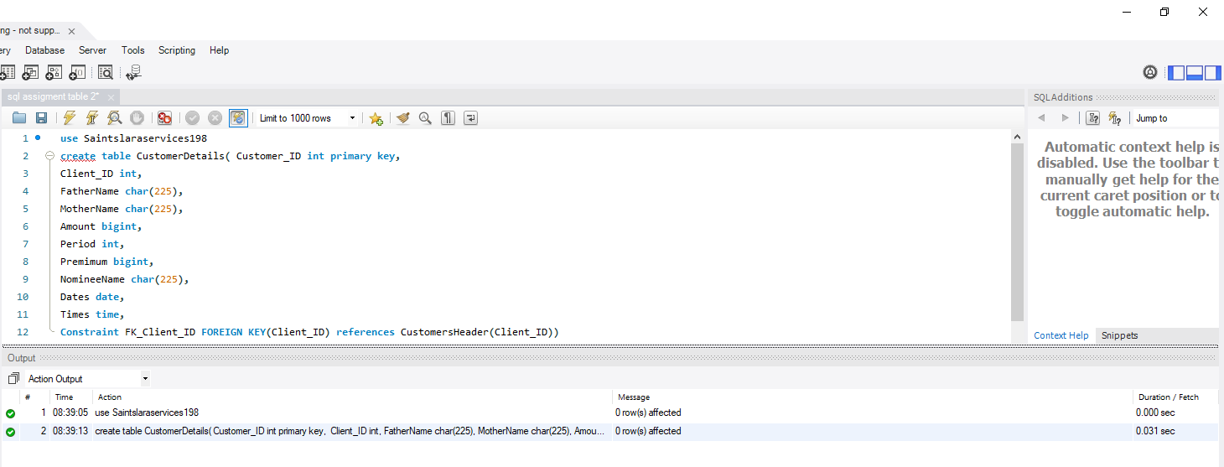***Commands & Query***
* 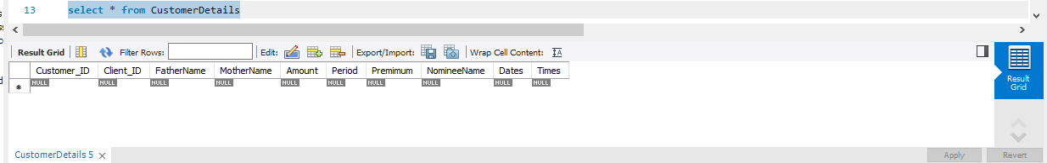***Display***

STEP 02

* Modify Add & Drop Column Command
* 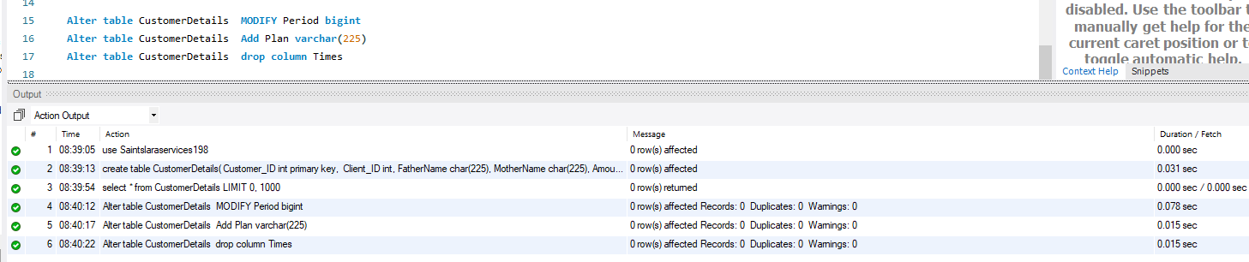***Commands & Query***
* 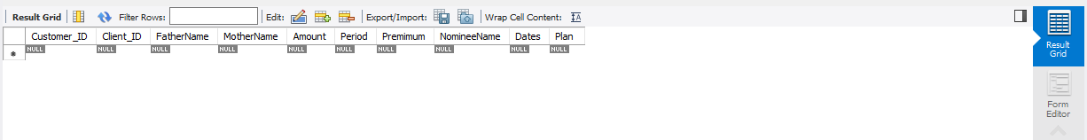***Display***

STEP 03

* Insert Data
* 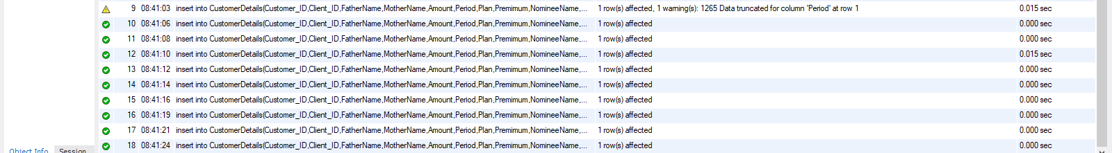***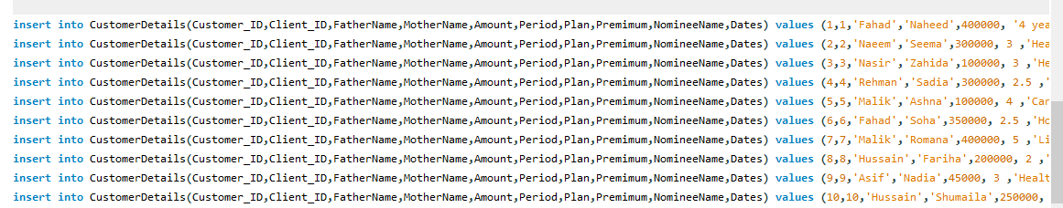Commands & Query***
* 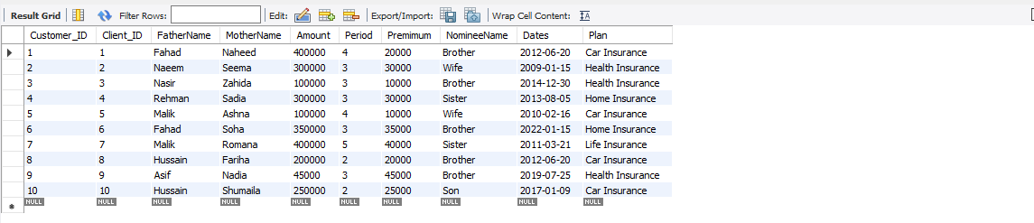***Display***

STEP 04

* Update Command
* ***Commands & Query***





* ***Display***

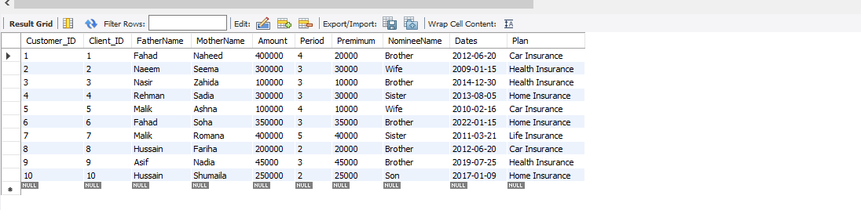

**COMPLETE VIEW**

